Factory Default
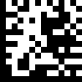 | Set
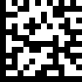 | Factory default settings | %++%
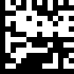 | End
Function | Command | Barcode | Remark
 | @SET
Factory Reset | WN-W-H0000 |  | - autoSetFactory  - The current spectrum constant  - Matching the address remains the sam  - The wireless channel is constant  - Locking band logo remains the same
 | @END

Scan Mode
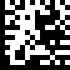 | Set
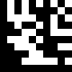 | Handheld Mode | MD01
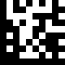 | Hands Free Mode | MD02
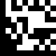 | Continue Scan | MD03
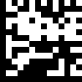 | End

Delay Time for Same Code
 | Set
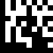 | 200 msec | SD0
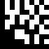 | 250 msec | SD1
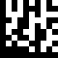 | 300 msec | SD2
 | End

Aiming Pattern
 | Set
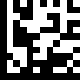 | On
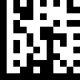 | Always On
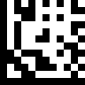 | Off
 | End

Keyboard Caps Lock State
 | Set
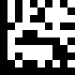 | Caps Lock Off | CS0
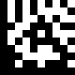 | Caps Lock On | CS1
 | End

Readable Codes
 | Set
 | Enable UPC-E | EC02
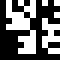 | Disable UPC-E | DC02
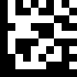 | Enable EAN 8 | EC03
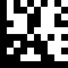 | Disable EAN 8 | DC03
 | End

Readable Codes
 | Set
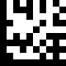 | Enable EAN 13 | EC04
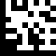 | Disable EAN 13 | DC04
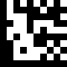 | Enable Code 128 | EC05
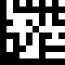 | Disable Code 128 | DC05
 | End

Readable Codes
 | Set
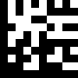 | Enable Code 39 | EC06
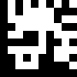 | Disable Code 39 | DC06
 | End

Readable Codes
 | Set
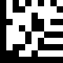 | Enable Codabar | EC10
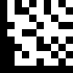 | Disable Codabar | DC10
 | End

Readable Codes
 | Set
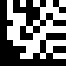 | Enable Interleaved 2 of 5 | EC13
 | Disable Interleaved 2 of 5 | DC13
 | End

Readable Codes
 | Set
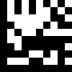 | Enable PDF417 | EC24
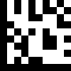 | Disable PDF417 | DC24
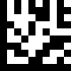 | Enable Micro PDF417 | EC25
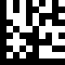 | Disable Micro PDF417 | DC25
 | End

Readable Codes
 | Set
 | Enable Data Matrix | EC26
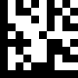 | Disable Data Matrix | DC26
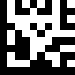 | Enable QR | EC27
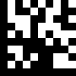 | Disable QR | DC27
 | End

UPC / EAN
 | Set
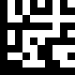 | Enable decoding of 2/5-digit supplemental code for UPC-A, UPC-E, EAN-13, and EAN-8 | UN01
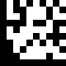 | Disable decoding of 2/5-digit supplemental code for UPC-A, UPC-E, EAN-13, and EAN-8 | UN02
 | End

UPC-A
 | Set
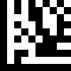 | Enable UPC-A Number System digit | UA01
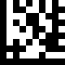 | Disable UPC-A Number System digit | UA02
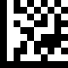 | Enable UPC-A check digit. | UA03
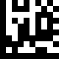 | Disable UPC-A check digit | UA04
 | End

UPC-A
 | Set
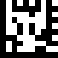 | Enable conversion of UPC-A to EAN13 | UA05
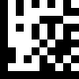 | Disable conversion of UPC-A to EAN13 | UA06
 | End

UPC-E
 | Set
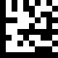 | Enable UPC-E Number System digit | UE01
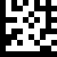 | Disable UPC-E Number System digit | UE02
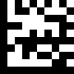 | Enable UPC-E check digit | UE03
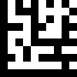 | Disable UPC-E check digit | UE04
 | End

UPC-E
 | Set
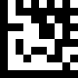 | Enable conversion of UPC-E to UPC-A | UE05
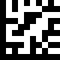 | Disable conversion of UPC-E to UPC-A | UE06
 | End

EAN 8
 | Set
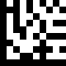 | Enable EAN 8 check digit | E801
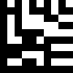 | Disable EAN 8 check digit | E802
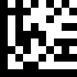 | Enable conversion of EAN 8 to EAN 13 | E803
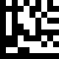 | Disable conversion of EAN 8 to EAN 13 | E804
 | End

EAN 13
 | Set
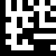 | Enable EAN 13 check digit | ED01
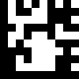 | Disable EAN 13 check digit | ED02
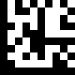 | Enable conversion of EAN 13 to ISBN | ED03
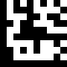 | Disable conversion of EAN 13 to ISBN | ED04
 | End

EAN 13
 | Set
 | Enable conversion of EAN 13 to ISSN | ED05
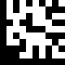 | Disable conversion of EAN 13 to ISSN | ED06
 | End

Code 39
 | Set
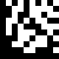 | Enable Code 39 full ASCII mode | C39a
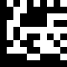 | Disable Code 39 full ASCII mode | C39b
 | Enable Start and Stop characters | C39c
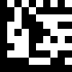 | Disable Start and Stop characters | C39d
 | End

Code 39
 | Set
 | Disable Checksum | C39e
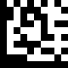 | Enable checksum and send check character | C39f
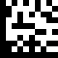 | Enable checksum and strip check character | C39g
 | End

Codabar
 | Set
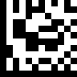 | Disable Checksum | CBRa
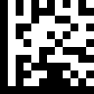 | Enable checksum and send check character | CBRb
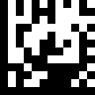 | Enable checksum and strip check character | CBRc
 | End

Interleaved 2 of 5
 | Set
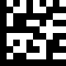 | Disable Checksum | I25a
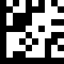 | Enable checksum and send check character | I25b
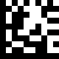 | Enable checksum and strip check character | I25c
 | End

Interleaved 2 of 5
 | Set
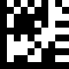 | Default quiet zone checking No length checking performed | I25d
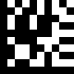 | Smaller quiet zone allowed | I25e
 | End

Data Matrix
 | Set
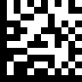 | Enable mirror decoding | DMXa
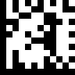 | Disable mirror decoding | DMXb
 | End

Data Matrix
 | Set
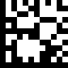 | Enable rectangular Data Matrix decoding | DMXc
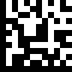 | Disable rectangular Data Matrix decoding | DMXd
 | End

QR / Micro QR
 | Set
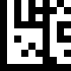 | Enable mirror decoding | QR01
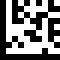 | Disable mirror decoding | QR02
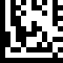 | UTF8 conversion for word only | QRC0
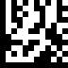 | Universal UTF8 conversion | QRC1
 | End

Set Lengths for Codes

One Discrete Length
Select this option to decode the symbol containing a selected length. Select the length using the numeric bar codes in ASCII Code Table. For example, to decode only Code 128 symbols with 14 characters, scan Code 128 One Discrete Length, then scan 1 followed by 4.

Two Discrete Lengths
Select this option to decode the symbol containing either of two selected lengths. Select lengths using the numeric bar codes in ASCII Code Table. For example, to decode only Code 128 symbols containing either 2 or 14 characters, select Code 128 Two Discrete Lengths, then scan 0, 2, 1, and
then 4.

Length Within Range
Select this option to decode the symbol with a specific length range.
Select lengths using numeric bar codes in ASCII Code Table. For example, to decode
Code 128 symbols containing between 4 and 12 characters, first scan Code 128 Length Within Range. Then scan 0, 4, 1, and 2.

Any Length
Select this option to decode the symbol containing any number of characters within the digital scanner’s capability.

Set Lengths for Code 128
 | Set
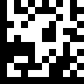 | One Discrete Length | ODL0
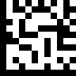 | Two Discrete Lengths | TDL0
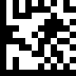 | Length Within Range | LWR0
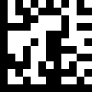 | Any Length | ANL0
 | End

Set Lengths for Code 39
 | Set
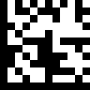 | One Discrete Length | ODL1
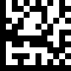 | Two Discrete Lengths | TDL1
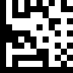 | Length Within Range | LWR1
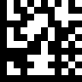 | Any Length | ANL1
 | End

Set Lengths for Codabar
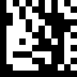 | Set
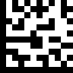 | One Discrete Length | ODL3
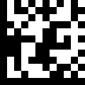 | Two Discrete Lengths | TDL3
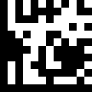 | Length Within Range | LWR3
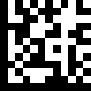 | Any Length | ANL3
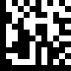 | End

Set Lengths for Interleaved 2 of 5
 | Set
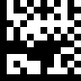 | One Discrete Length | ODL4
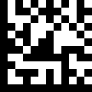 | Two Discrete Lengths | TDL4
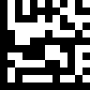 | Length Within Range | LWR4
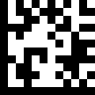 | Any Length | ANL4
 | End

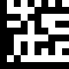 | 0 | N0
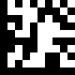 | 1 | N1
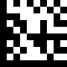 | 2 | N2
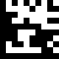 | 3 | N3
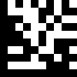 | 4 | N4

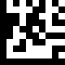 | 5 | N5
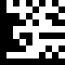 | 6 | N6
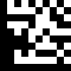 | 7 | N7
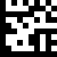 | 8 | N8
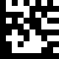 | 9 | N9

Code Identifiers
 | Set
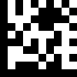 | Disable Code ID | $D0
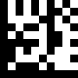 | Enable AIM ID | $D1
 | End

Symbology | AIM
UPC-A | ]E
UPC-E | ]E
EAN 8 | ]E
EAN 13 | ]E
Code 128 | ]C
Code 39 | ]A
Code 93 | ]G
Code 32 | ]X
Codabar | ]F
Plessey | ]P
Interleaved 2 of 5 | ]I
IATA 2 of 5 | ]R
Matrix 2 of 5 | ]X
Straight 2 of 5 | ]S
Pharmacode | ]X
RSS Limited | ]e
Component CC-A | ]e
Component CC-B | ]e
Component CC-C | ]e
PDF417 | ]L
Micro PDF417 | ]L
Data Matrix | ]d
QR | ]Q
Micro QR | ]Q
Aztec | ]Z

Pairing ★
Function | Command | Barcode | Remark
Enter setting | @.WN-T-A0001/ |  | Power off when pairing failed.  When the pairing is successful, the engine to continue running.
Discharge pairing | @.WN-T-A0000/ |  | Discharge pairing
Notice☆:1、Matching effective time starts timing receiver just electricity 20 s time on (LED flashing status).After 20 s LED normally on can't match.(this way for no keys of receiving)
2、Press buttons on the receiver, the receiver will automatically enter the matching state, during this period can be paired normally. (with button this way for receiving).
3、2.4 G namely stop flashing after matching success, 433 at boot after 20 s to stop flashing

4.2 HID-KEYBOARD Language setting★
Function | Command | Barcode | Remark
 | @SET
*USA | WN-W-B1000 |  | *USA
FRENCH | WN-W-B1001 |  | FRENCH
GEMRAN | WN-W-B1002 |  | GEMRAN
TUKISH | WN-W-B1003 |  | TUKISH
BELGIUM | WN-W-B1004 |  | BELGIUM
BRAZIL | WN-W-B1005 |  | BRAZIL
CRZCH | WN-W-B1006 |  | CRZCH
SPANISH | WN-W-B1007 |  | SPANISH
 | @END
Note★：This setting is on the receiving end (Tx) and the sender (Rx) effectively at the same time. If in the case of wireless transmission connection set multiple languages, can lead to the sender language setting is successful, the receiver without language change.。

4.3 To change the frequency of the wireless reception
Function | Command | Barcode | Remark
 | @SET
- To change the receiving address | WN-R-C0000 |  | Methods①：Automatic
 | @END
Note★:After change the frequency of wireless reception , Need to plug the receiver and pairing

4.4 Check the parameters
Function | Command | Barcode | Remark
 | @SET
Print the system parameters | WN-W-C1000 |  | - firmware version  - Battery  - wireless spectrum  - wireless channel  - receive address
 | @END
Instructions☆：being check parameters command with the system parameters to receive, terminators after each parameter is separated, such as: PKT {protocol field | WN - W - B1001 | parameter 1 + 0 x0d | parameter 2 + 0 x0d |...}, {} for the contents of the packet)

4.5 Working mode★
Function | Command | Barcode |  | Remark
*Real-time mode | @.WN-T-F0000/ |  |  | Scan and transmit, data will automatically lost if  upload failed.
Cache mode | @.WN-T-F1000/ |  |  | Same as real time mode if connection normal. Scan barcodes will be automatically restore if connection failed. Will upload one by one if connection return as normal.
Inventory mode | @.WN-T-F2000/ |  |  | 条码数据自动存储起来，扫“上传数据”之后一次性上传；扫“清除数据”清空存储器中的数据‘扫“数据总数”可查看存储器中的数据总数  Scanning barcodes will be restored without upload. Will upload once scan “Upload data” barcode. Will clear once scan “Clear data” .Will check sum once scan” Data sum”
Upload data | @.WN-T-F2001/ |  | Upload barcode data
Data sum | @.WN-T-F2002/ |  | Upload the sum of barcode
Clear data | @.WN-T-F2003/ |  | To clean the data of barcode
Instructions：☆:1、Working mode of six instructions for quick setup, state changes save directly, without scanning into the keep out of the setup instructions and instructions; Work mode of "real time" mode, "cache model", "inventory model" in the scanned into the setting after scanning is a quick instruction set, need save to exit the Settings take effect;
2、Inventory mode 【upload data】, 【Data sum】, 【the clear data】 three operation setting commands in enter setting state is not available, when using the three operation setting commands if has entered the set state, after the need to save first, just can use.
3、Store the length of 30 byte barcode data, inventory model can store 46000, normal cache can store more than 15000.
4.6 Sleep times setting★
Function | Command | Barcode | Remark
 | @SET
*20 sec | WN-T-G0001
60 sec | WN-T-G0003
3 min | WN-T-G0009
5 min | WN-T-G0015
15 min | WN-T-G0045
30 min | WN-T-G0090
non-sleep | WN-T-G0000 |  | After startup, with no sleep (applicable to when used to connect wireless scanner cable can be set to no sleep, no sleep mode is not recommended)
 | @END
Instructions☆: The calculation method of sleep time：20 * x = n (ms) , X for barcode after two decimal values

4.8 The command of firmware upgrade
Function | Command | Barcode | Remark
 | @SET
Receiver upgrade | WN-R-K0000 |  | 1. Receive PC via USB way connection, and in the case of pairs, scanning the barcode after Saul, receiving end after receiving the plug again  2. Receive a PC via RS232 serial interface mode connection, scanning the barcode after Saul, receiving end after receiving the plug again  3. Receive a PC via a serial port connection, hold down the button at the bottom for 8 s after system in upgrade mode
Sender upgrade | WN-T-K0000 |  | 1. The PC via USB cable connection, and then send the upgrade barcode, upgrade equipment to restart after testing
 | @END

4.9 Wireless connectivity detection(★Note: this function only in a scanner connected to a receiver)
Function | Command | Barcode | Remark
 | @SET
Enable connection test | WN-T-C0001 |  | This setting only in a scanner connected to a receiver
*Disable connection test | WN-T-C0002 |  | When more than a scanner connected a receiving a case, need to close the connection test, factory default is close the connection test
 | @END

4.10 The sender wired output
Function | Command | Barcode | Remark
 | @SET
* Enable USB wired output | WN-T-L0000 |  | 1. After open the sender after the PCB via USB cable connection, connection can be directly through the normal USB transmission, do not use the wireless transmission
Disable USB wired output | WN-T-L0001 |  | Shut down after insert USB cable only allows charging, only through wireless data transmission
 | @END
Note☆:USB wired output is used only for the sender

4.11 Wired connection (USB/USB VCP COM) ★
Function | Command | Barcode | Remark
 | @SET
*USB mode | WN-W-L1000 |  | USB interface
USB VCP COM | WN-W-L1001 |  | USB virtual serial port need to install the serial port (USB) driver can be normal use
RS232 mode | WN-R-L1002 |  | 1, a serial port output function only in support of a serial port output devices (hardware) can use, now only RF433 receive support serial output 2, optimizes the transmission way of new products. USB and RS232 serial port transmission can automatically identify, do not need to set up a serial port output
RS485 mode | WN-R-L1004
 | @END
注意★：1. The default for USB and RS232 serial Port output, the system will automatically choose the USB or RS232 serial Port output according to the hardware, without setting 2. USB and Virtual serial Port (Virtual COM Port) when switching need scan Settings to change, but don't need to plug the receiver
4.12 Serial port setting ★
Function | Command | Barcode | Remark
 | @SET | 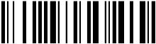
3.10.1 Baud rate
2400 | WN-R-D0000
4800 | WN-R-D0001
*9600 | WN-R-D0002
19200 | WN-R-D0003
38400 | WN-R-D0004
57600 | WN-R-D0005
115200 | WN-R-D0006
3.10.2 The length of the data
7 Data Bits | WN-R-D1002
*8 Data Bits | WN-R-D1001
3.10.3 Stop bit
*1 Stop Bit | WN-R-D1003
2 Stop Bit | WN-R-D1004
3.10.4 Parity bit
*No Parity | WN-R-D1005
Odd Parity | WN-R-D1006
Even Parity | WN-R-D1007
 | @END
Note★：The serial port setting can be used normal on support serial output equipment only

4．13 Auto trigger
Function | Command | Barcode | Remark
 | @SET
Enable auto trigger | WN-T-D0000 |  | Enable infrared induction trigger
Disable auto trigger | WN-T-D0001 |  | Disable infrared induction trigger
 | @END

4.14 Start symbol mode setting ★
Function | Command | Barcode | Remark
 | @SET
*No start symbol | WN-T-I0000
Custom start symbol+barcode | WN-T-I0002
 | @END
The sample of start symbol mode setting：To set a start symbol “#Ab9”in barcode “1234567”,The barcode data will be “#Ab91234567”.
1.Scan 【@SET】barcode.
2.Scan 【Custom start symbol + bar code】
3.Scan the following symbol【#】、【A】、【b】、【9】 in turn.
4.Scan 【@END】barcode.

4.15 End symbol mode setting
Function | Command | Barcode | Remark
 | @SET
No end symbol | WN-T-I1000 |  | No end symbol
Custom end symbol | WN-T-I100A |  | Custom end symbol can be composed of ASCII codes of any character, customers can set according to need
 | @END
The sample of end symbol mode setting：To set a start symbol “%B”in barcode “1234567”,The barcode data will be “1234567%B”.
1.Scan【@SET】barcode ->2.Scan【Custom end symbol】barcode ->3. Scan the following symbol【%】、【B】、in turn
4.Scan【Exit&Save】barcode
5. End symbol of factory reset: 0x0D(Enter)
6. End symbol of commonly used symbols： 0x0D(Enter)，0x0A，0x09(Tab)
0x0D(Enter) | 0x0A(Line feed) | 0x09(Tab)

Symbol table

Control symbol | Hex
^@（NULL） | 00
^A（SOH） | 01
^B（STX） | 02
^C（ETX） | 03
^D（EOT） | 04
^E（ENQ） | 05
^F（ACK） | 06
^G（BEL） | 07
^H（BS） | 08
^I（HTab） | 09
^J（LF） | 0A
^K（VTab） | 0B
^L（FF） | 0C
^M（CR） | 0D
^N（SO） | 0E
^O（SI） | 0F
^P（DLE） | 10
^Q（DC1） | 11
^R（DC2） | 12
^S（DC3） | 13
^T（DC4） | 14
^U（NAK） | 15
^V（SYN） | 16
^W（ETB） | 17
^X（CAN） | 18
^Y（EM） | 19
^Z（SUB） | 1A
^[（ESC） | 1B
^\（FS） | 1C
^]（GS） | 1D
^^（RS） | 1E
^_（US） | 1F
SPC | 20
Symbol | Hex
! | 21
" | 22
# | 23
$ | 24
% | 25
& | 26
' | 27
( | 28
) | 29
* | 2A
+ | 2B
, | 2C
- | 2D
. | 2E
/ | 2F
0 | 30
1 | 31
2 | 32
3 | 33
4 | 34
5 | 35
6 | 36
7 | 37
8 | 38
9 | 39
: | 3A
; | 3B
< | 3C
= | 3D
> | 3E
? | 3F
@ | 40
A | 41
B | 42
C | 43
D | 44
E | 45
F | 46
G | 47
H | 48
I | 49
J | 4A
K | 4B
L | 4C
M | 4D
N | 4E
O | 4F
P | 50
Q | 51
R | 52
S | 53
T | 54
U | 55
V | 56
W | 57
X | 58
Y | 59
Z | 5A
[ | 5B
\ | 5C
] | 5D
^ | 5E
_ | 5F
` | 60
a | 61
b | 62
c | 63
d | 64
e | 65
f | 66
g | 67
h | 68
i | 69
j | 6A
k | 6B
l | 6C
m | 6D
n | 6E
o | 6F
p | 70
q | 71
r | 72
s | 73
t | 74
u | 75
v | 76
w | 77
x | 78
Y | 79
z | 7A
{ | 7B
| | 7C
} | 7D
~ | 7E
DEL | 7F
Function keys | Hex
F1 | 80
F2 | 81
F3 | 82
F4 | 83
F5 | 84
F6 | 85
F7 | 86
F8 | 87
F9 | 88
F10 | 89
F11 | 8A | 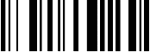
F12 | 8B
Backspace | 8C
Tab | 8D | 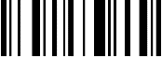
Return（ENTER） | 8E
Enter（Numeric Keypad） | 8F
Esc | 90
Arrow Down | 91
Arrow up | 92
Arrow right | 93 | 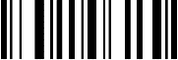
Arrow left | 94
Insert | 95
Home | 96
End | 97
Page up | 98 | 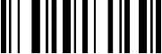
Page down | 99
Left Shift | 9A
Left Ctrl | 9B
Left Alt | 9C
Left GUI | 9D
Right Shift | 9E
Right Ctrl | 9F
Right Alt | A0
Right GUI | A1
Caps Lock | A2

