Factory Default
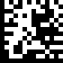 | Set
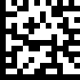 | Factory default settings | %++%
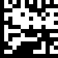 | End

Interface
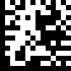 | Set
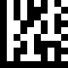 | RS232 | OP01
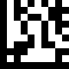 | USB Keyboard | OP02
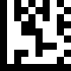 | USB Virtual COM Port | OP03
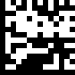 | End

Scan Mode
 | Set
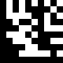 | Handheld Mode | MD01
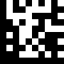 | Hands Free Mode | MD02
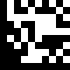 | Continue Scan | MD03
 | End

Delay Time for Same Code
 | Set
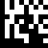 | 200 msec | SD0
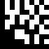 | 250 msec | SD1
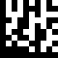 | 300 msec | SD2
 | End

Aiming Pattern
 | Set
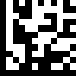 | On
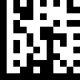 | Always On
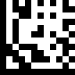 | Off
 | End

Keyboard Caps Lock State
 | Set
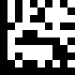 | Caps Lock Off | CS0
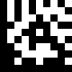 | Caps Lock On | CS1
 | End

Readable Codes
 | Set
 | Enable UPC-E | EC02
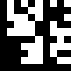 | Disable UPC-E | DC02
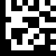 | Enable EAN 8 | EC03
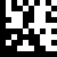 | Disable EAN 8 | DC03
 | End

Readable Codes
 | Set
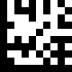 | Enable EAN 13 | EC04
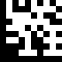 | Disable EAN 13 | DC04
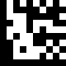 | Enable Code 128 | EC05
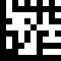 | Disable Code 128 | DC05
 | End

Readable Codes
 | Set
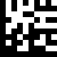 | Enable Code 39 | EC06
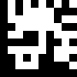 | Disable Code 39 | DC06
 | End

Readable Codes
 | Set
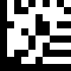 | Enable Codabar | EC10
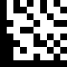 | Disable Codabar | DC10
 | End

Readable Codes
 | Set
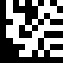 | Enable Interleaved 2 of 5 | EC13
 | Disable Interleaved 2 of 5 | DC13
 | End

Readable Codes
 | Set
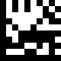 | Enable PDF417 | EC24
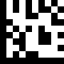 | Disable PDF417 | DC24
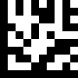 | Enable Micro PDF417 | EC25
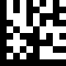 | Disable Micro PDF417 | DC25
 | End

Readable Codes
 | Set
 | Enable Data Matrix | EC26
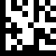 | Disable Data Matrix | DC26
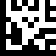 | Enable QR | EC27
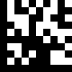 | Disable QR | DC27
 | End

UPC / EAN
 | Set
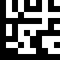 | Enable decoding of 2/5-digit supplemental code for UPC-A, UPC-E, EAN-13, and EAN-8 | UN01
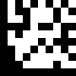 | Disable decoding of 2/5-digit supplemental code for UPC-A, UPC-E, EAN-13, and EAN-8 | UN02
 | End

UPC-A
 | Set
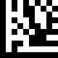 | Enable UPC-A Number System digit | UA01
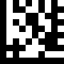 | Disable UPC-A Number System digit | UA02
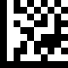 | Enable UPC-A check digit. | UA03
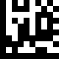 | Disable UPC-A check digit | UA04
 | End

UPC-A
 | Set
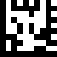 | Enable conversion of UPC-A to EAN13 | UA05
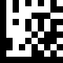 | Disable conversion of UPC-A to EAN13 | UA06
 | End

UPC-E
 | Set
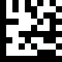 | Enable UPC-E Number System digit | UE01
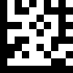 | Disable UPC-E Number System digit | UE02
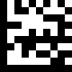 | Enable UPC-E check digit | UE03
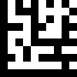 | Disable UPC-E check digit | UE04
 | End

UPC-E
 | Set
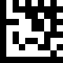 | Enable conversion of UPC-E to UPC-A | UE05
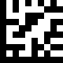 | Disable conversion of UPC-E to UPC-A | UE06
 | End

EAN 8
 | Set
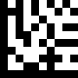 | Enable EAN 8 check digit | E801
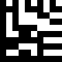 | Disable EAN 8 check digit | E802
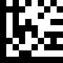 | Enable conversion of EAN 8 to EAN 13 | E803
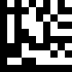 | Disable conversion of EAN 8 to EAN 13 | E804
 | End

EAN 13
 | Set
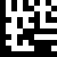 | Enable EAN 13 check digit | ED01
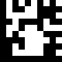 | Disable EAN 13 check digit | ED02
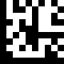 | Enable conversion of EAN 13 to ISBN | ED03
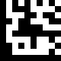 | Disable conversion of EAN 13 to ISBN | ED04
 | End

EAN 13
 | Set
 | Enable conversion of EAN 13 to ISSN | ED05
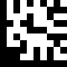 | Disable conversion of EAN 13 to ISSN | ED06
 | End

Code 39
 | Set
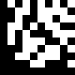 | Enable Code 39 full ASCII mode | C39a
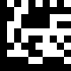 | Disable Code 39 full ASCII mode | C39b
 | Enable Start and Stop characters | C39c
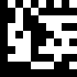 | Disable Start and Stop characters | C39d
 | End

Code 39
 | Set
 | Disable Checksum | C39e
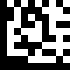 | Enable checksum and send check character | C39f
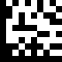 | Enable checksum and strip check character | C39g
 | End

Codabar
 | Set
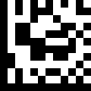 | Disable Checksum | CBRa
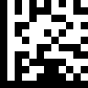 | Enable checksum and send check character | CBRb
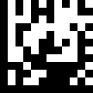 | Enable checksum and strip check character | CBRc
 | End

Interleaved 2 of 5
 | Set
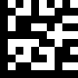 | Disable Checksum | I25a
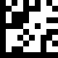 | Enable checksum and send check character | I25b
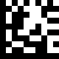 | Enable checksum and strip check character | I25c
 | End

Interleaved 2 of 5
 | Set
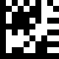 | Default quiet zone checking No length checking performed | I25d
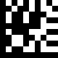 | Smaller quiet zone allowed | I25e
 | End

Data Matrix
 | Set
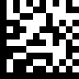 | Enable mirror decoding | DMXa
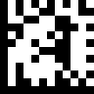 | Disable mirror decoding | DMXb
 | End

Data Matrix
 | Set
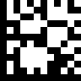 | Enable rectangular Data Matrix decoding | DMXc
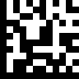 | Disable rectangular Data Matrix decoding | DMXd
 | End

QR / Micro QR
 | Set
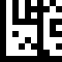 | Enable mirror decoding | QR01
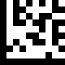 | Disable mirror decoding | QR02
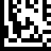 | UTF8 conversion for word only | QRC0
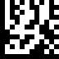 | Universal UTF8 conversion | QRC1
 | End

Set Lengths for Codes

One Discrete Length
Select this option to decode the symbol containing a selected length. Select the length using the numeric bar codes in ASCII Code Table. For example, to decode only Code 128 symbols with 14 characters, scan Code 128 One Discrete Length, then scan 1 followed by 4.

Two Discrete Lengths
Select this option to decode the symbol containing either of two selected lengths. Select lengths using the numeric bar codes in ASCII Code Table. For example, to decode only Code 128 symbols containing either 2 or 14 characters, select Code 128 Two Discrete Lengths, then scan 0, 2, 1, and
then 4.

Length Within Range
Select this option to decode the symbol with a specific length range.
Select lengths using numeric bar codes in ASCII Code Table. For example, to decode
Code 128 symbols containing between 4 and 12 characters, first scan Code 128 Length Within Range. Then scan 0, 4, 1, and 2.

Any Length
Select this option to decode the symbol containing any number of characters within the digital scanner’s capability.

Set Lengths for Code 128
 | Set
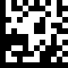 | One Discrete Length | ODL0
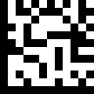 | Two Discrete Lengths | TDL0
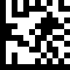 | Length Within Range | LWR0
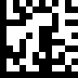 | Any Length | ANL0
 | End

Set Lengths for Code 39
 | Set
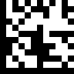 | One Discrete Length | ODL1
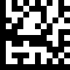 | Two Discrete Lengths | TDL1
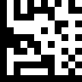 | Length Within Range | LWR1
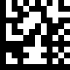 | Any Length | ANL1
 | End

Set Lengths for Codabar
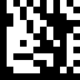 | Set
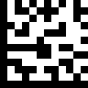 | One Discrete Length | ODL3
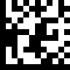 | Two Discrete Lengths | TDL3
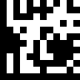 | Length Within Range | LWR3
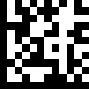 | Any Length | ANL3
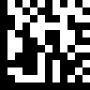 | End

Set Lengths for Interleaved 2 of 5
 | Set
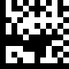 | One Discrete Length | ODL4
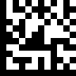 | Two Discrete Lengths | TDL4
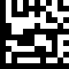 | Length Within Range | LWR4
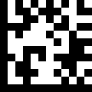 | Any Length | ANL4
 | End

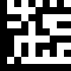 | 0 | N0
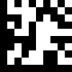 | 1 | N1
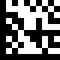 | 2 | N2
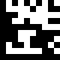 | 3 | N3
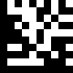 | 4 | N4

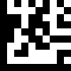 | 5 | N5
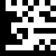 | 6 | N6
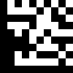 | 7 | N7
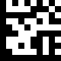 | 8 | N8
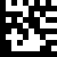 | 9 | N9

Code Identifiers
 | Set
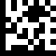 | Disable Code ID | $D0
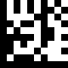 | Enable AIM ID | $D1
 | End

Symbology | AIM
UPC-A | ]E
UPC-E | ]E
EAN 8 | ]E
EAN 13 | ]E
Code 128 | ]C
Code 39 | ]A
Code 93 | ]G
Code 32 | ]X
Codabar | ]F
Plessey | ]P
Interleaved 2 of 5 | ]I
IATA 2 of 5 | ]R
Matrix 2 of 5 | ]X
Straight 2 of 5 | ]S
Pharmacode | ]X
RSS Limited | ]e
Component CC-A | ]e
Component CC-B | ]e
Component CC-C | ]e
PDF417 | ]L
Micro PDF417 | ]L
Data Matrix | ]d
QR | ]Q
Micro QR | ]Q
Aztec | ]Z

Prefix
 | Set
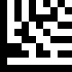 | Enable All | EP00
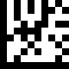 | Disable All | DP00
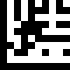 | Enable UPC-A | EP01
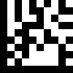 | Disable UPC-A | DP01
 | End

Prefix
 | Set
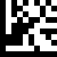 | Enable UPC-E | EP02
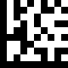 | Disable UPC-E | DP02
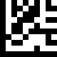 | Enable EAN 8 | EP03
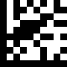 | Disable EAN 8 | DP03
 | End

Prefix
 | Set
 | Enable EAN 13 | EP04
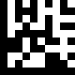 | Disable EAN 13 | DP04
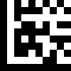 | Enable Code 128 | EP05
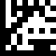 | Disable Code 128 | DP05
 | End

Prefix
 | Set
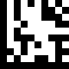 | Enable Code 39 | EP06
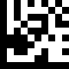 | Disable Code 39 | DP06
 | End

Prefix
 | Set
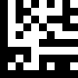 | Enable Codabar | EP10
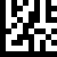 | Disable Codabar | DP10
 | End

Prefix
 | Set
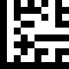 | Enable Interleaved 2 of 5 | EP13
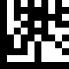 | Disable Interleaved 2 of 5 | DP13
 | End

Prefix
 | Set
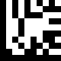 | Enable PDF417 | EP24
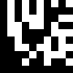 | Disable PDF417 | DP24
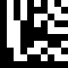 | Enable Micro PDF417 | EP25
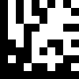 | Disable Micro PDF417 | DP25
 | End

Prefix
 | Set
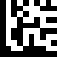 | Enable Data Matrix | EP26
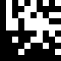 | Disable Data Matrix | DP26
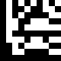 | Enable QR | EP27
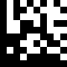 | Disable QR | DP27
 | End

Prefix
 | Set
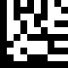 | Enable Micro QR | EP28
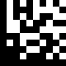 | Disable Micro QR | DP28
 | End

Suffix
 | Set
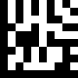 | Enable All | ES00
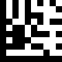 | Disable All | DS00
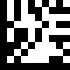 | Enable UPC-A | ES01
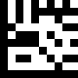 | Disable UPC-A | DS01
 | End

Suffix
 | Set
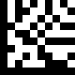 | Enable UPC-E | ES02
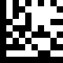 | Disable UPC-E | DS02
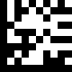 | Enable EAN 8 | ES03
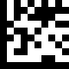 | Disable EAN 8 | DS03
 | End

Suffix
 | Set
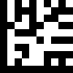 | Enable EAN 13 | ES04
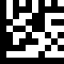 | Disable EAN 13 | DS04
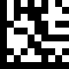 | Enable Code 128 | ES05
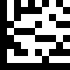 | Disable Code 128 | DS05
 | End

Suffix
 | Set
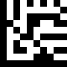 | Enable Code 39 | ES06
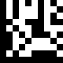 | Disable Code 39 | DS06
 | End

Suffix
 | Set
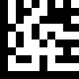 | Enable Codabar | ES10
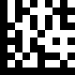 | Disable Codabar | DS10
 | End

Suffix
 | Set
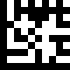 | Enable Interleaved 2 of 5 | ES13
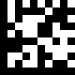 | Disable Interleaved 2 of 5 | DS13
 | End

Suffix
 | Set
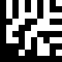 | Enable PDF417 | ES24
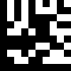 | Disable PDF417 | DS24
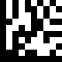 | Enable Micro PDF417 | ES25
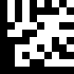 | Disable Micro PDF417 | DS25
 | End

Suffix
 | Set
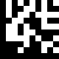 | Enable Data Matrix | ES26
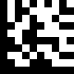 | Disable Data Matrix | DS26
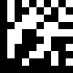 | Enable QR | ES27
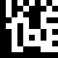 | Disable QR | DS27
 | End

Suffix
 | Set
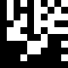 | Enable Micro QR | ES28
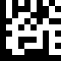 | Disable Micro QR | DS28
 | End

ASCII Code Table
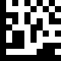 | Insert | K1
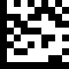 | Delete | K2
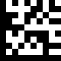 | Home | K3
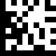 | End | K4
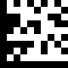 | Up arrow | K5
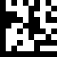 | Down arrow | K6

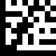 | Left arrow | K7
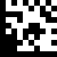 | Right arrow | K8
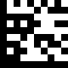 | TAB | K9
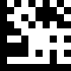 | Backspace | K10
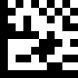 | Shift | K11
 | ESC | K12

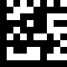 | Page up | K13
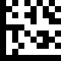 | Page down | K14
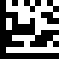 | F1 | F1
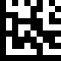 | F2 | F2
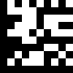 | F3 | F3
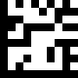 | F4 | F4

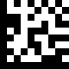 | F5 | F5
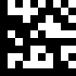 | F6 | F6
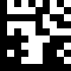 | F7 | F7
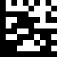 | F8 | F8
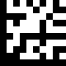 | F9 | F9
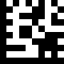 | F10 | F10

 | F11 | F11
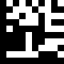 | F12 | F12
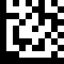 | SPACE | S0
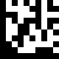 | ! | S1
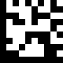 | " | S2
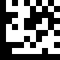 | # | S3

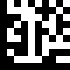 | $ | S4
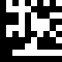 | % | S5
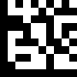 | & | S6
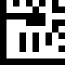 | ' | S7
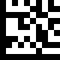 | ( | S8
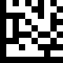 | ) | S9

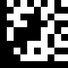 | * | S10
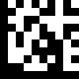 | + | S11
 | , | S12
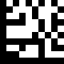 | - | S13
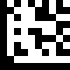 | . | S14
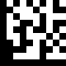 | / | S15

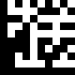 | : | B0
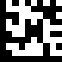 | ; | B1
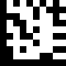 | < | B2
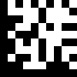 | = | B3
 | > | B4
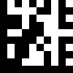 | ? | B5

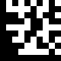 | @ | B6
 | 0 | N0
 | 1 | N1
 | 2 | N2
 | 3 | N3
 | 4 | N4

 | 5 |  | N5
 | 6 |  | N6
 | 7 |  | N7
 | 8 |  | N8
 | 9 |  | N9
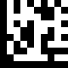 | ASCII Code | Function Key Mapping | $A
 | A | Ctrl+a

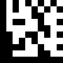 | ASCII Code | Function Key Mapping | $B
 | B | Ctrl+b
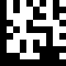 | C | Ctrl+c | $C
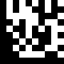 | D | Ctrl+d | $D
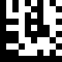 | E | Ctrl+e | $E
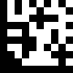 | F | Ctrl+f | $F
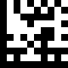 | G | Ctrl+g | $G

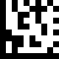 | ASCII Code | Function Key Mapping | $H
 | H | Ctrl+h
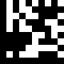 | I | Ctrl+i | $I
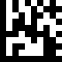 | J | Ctrl+j | $J
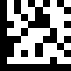 | K | Ctrl+k | $K
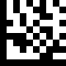 | L | Ctrl+l | $L
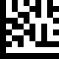 | M | Ctrl+m | $M

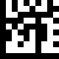 | ASCII Code | Function Key Mapping | $N
 | N | Ctrl+n
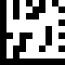 | O | Ctrl+o | $O
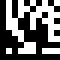 | P | Ctrl+p | $P
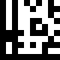 | Q | Ctrl+q | $Q
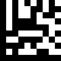 | R | Ctrl+r | $R
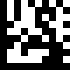 | S | Ctrl+s | $S

 | ASCII Code | Function Key Mapping | $T
 | T | Ctrl+t
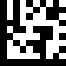 | U | Ctrl+u | $U
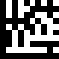 | V | Ctrl+v | $V
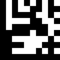 | W | Ctrl+w | $W
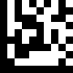 | X | Ctrl+x | $X
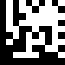 | Y | Ctrl+y | $Y

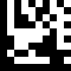 | ASCII Code | Function Key Mapping | $Z
 | Z | Ctrl+z
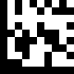 | a |  | +A
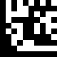 | b |  | +B
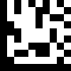 | c |  | +C
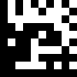 | d |  | +D
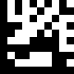 | e |  | +E

 | f | +F
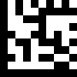 | g | +G
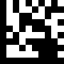 | h | +H
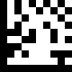 | i | +I
 | j | +J
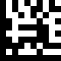 | k | +K

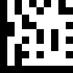 | l | +L
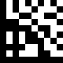 | m | +M
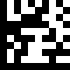 | n | +N
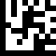 | o | +O
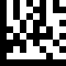 | p | +P
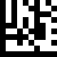 | q | +Q

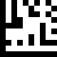 | r | +R
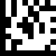 | s | +S
 | t | +T
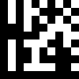 | u | +U
 | v | +V
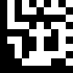 | w | +W

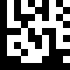 | x | +X
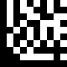 | y | +Y
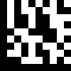 | z | +Z

